ORIGINAL ARTICLE: 22nd July 26 edition of the 14 AI patients using the 400nmol/L cut-off

Adrenal insufficiency occurs in a significant proportion of advanced HIV cases: Artificial intelligence enhances diagnostic accuracy
TRP Mofokeng1, A Grossman2, RS Millar3, TS Pillay4, C Dandara5, R Erasmus6, G Johansson7, JB Sempa8, B Aslan9, G Nitschke9, J Singbo10, J Dave10, NS Levitt10, PJ Raubenheimer10, IL Ross10

1 Division of Endocrinology, Department of Medicine University of the Free State, South Africa
2 Centre for Endocrinology, Barts and the London School of Medicine and Dentistry, Queen Mary University of London, UK, and Green Templeton College, University of Oxford, UK
3 Department of Immunology, Faculty of Health Sciences, University of Pretoria, Private Bag X323, Pretoria 0031, South Africa
4 Department of Chemical Pathology and National health Laboratory Servi Tshwane Academic Division, Faculty of Health Sciences, University of Pretoria, South Africa
5 Division of Human Genetics, University of Cape Town
6 Tygerberg Hospital, National Health Laboratory Service, Faculty of Medicine, Stellenbosch University, Cape Town, South Africa
7 Department of Endocrinology, Sahlgrenska Academy, Sahlgrenska University Hospital and Institute of Medicine, University of Gothenburg, Gothenburg, Sweden
8 Department of Statistics, University of the Free State, South Africa
9 Department of Computer Science, University of Cape Town, South Africa
10 Division of Endocrinology, Department of Medicine, University of Cape Town, South Africa

Correspondence should be addressed to:
Prof Thabiso RP Mofokeng,
Division of Endocrinology,
Department of Medicine (University of the Free State) South Africa,
e-mail: mofokengtrp@ufs.ac.za

Abstract:
Background:
Sub-Saharan Africa is burdened by a vast HIV-positive population, at risk of life-threatening AIDS-defining illnesses, associated with primary (PAI) and secondary adrenal insufficiency (SAI). We hypothesised that adrenal insufficiency (AI) may partially account for the high mortality in advanced HIV.

Materials & Methods:
We undertook a prospective case-finding study of HIV-positive patients presenting with advanced disease, older than 18 years, a CD4 count of less than 100 cells/mm³, and a coexistent opportunistic infection. Exclusion criteria were the use of oral, intravenous, topical or inhaled steroids in the previous 3 months.

Results:
Of 589 patients recruited, 563 had complete records. The median interquartile range (IQR) age of patients at enrolment was 36.0 years (IQR: 31.0-43.0). Patients in the lowest CD4 tertile and highest viral loads were younger and were more likely to have Candida albicans than in the remaining CD4 tertiles; p=0.003 and p<0.001, respectively. Of 563 patients, 14 (2.49%) had AI diagnosed with a 30 minute stimulated serum cortisol < 400nmol and 21 (3.73%), using a random serum cortisol <274 nmol/L. Cryptococcus neoformans predominated in the AI-group (42.9% vs 4.3%), p=0.001.
The overall one-year mortality for the whole cohort was 29.66%, Cryptococcus predominated in the AI-group 60% vs 5.7% (p=0.028). Regression analysis revealed that a 50 nmol/L cortisol increase and 100 pg/L increase in plasma ACTH were associated with a 14% and 117% increase in the odds of death (OR = 1.14, (95%CI: 1.08, 1.21); p<0.001) and (OR = 2.17, (95%CI: 1.35, 3.72) (p<0.003), respectively. Patients with AI had better survival at 12 months, compared with those without AI (p=0.037). Our machine learning AI neural network model successfully predicted AI with 100% sensitivity and 80.5% specificity, respectively.

Conclusion:
The largest African study to date of hypoadrenalism in advanced HIV revealed AI incidence of 6.22%, and overall, one-year mortality of 29.66%. Cryptococcus neoformans predominated in the AI group and was associated with a higher mortality. We developed a neural network model which accurately predicted adrenal insufficiency. Treatment of AI may have survival benefit at 12 months after hospitalisation.

HAART – Highly Active Anti-Retroviral Therapy, PTB – pulmonary tuberculosis, EPTB – Extrapulmonary tuberculosis

Introduction
Adrenal insufficiency (AI) is invariably fatal without appropriate replacement. Prior to glucocorticoids, most patients with primary adrenal insufficiency (PAI) died within 2 years of diagnosis [1]. Autoimmune AI predominates both in European populations [2] and also in South Africa [3], despite the high background prevalence of tuberculosis (TB) [4]. However, our recent African survey suggests that PAI is attributable to TB and Acquired Immune Deficiency Syndrome (AIDS) in 34% and 29.8%, respectively [5].
The background prevalence of Human Immunodeficiency Virus (HIV) in sub-Saharan Africa is 9% [6, 7], with lower mortality in better resourced settings, [8] due to earlier presentation and adequate funding, compared with limited resourced health systems. I. Patients with HIV may develop PAI due to inter alia TB, Mycobacterium avium intracellulare (MAI), cytomegalovirus (CMV), toxoplasmosis, Pneumocystis carinii, histoplasmosis, and malignancies for example, non-Hodgkin’s lymphoma and Kaposi sarcoma (KS). Fungal infections including cryptococcus, blastomycosis, and histoplasmosis, and various medications including ketoconazole and mitotane, may cause PAI [9]. Secondary adrenal insufficiency (SAI) in HIV may be due to inter alia TB, toxoplasmosis and CMV. I I[10] [11, 12].
The reported incidence of hypoadrenalism in patients with HIV varies. In a study in Pakistan by Afreen et al, of 64 HIV infected patients, predominantly male (84.9%), the AI incidence was 9 (14.0%), using the 250 µg intravenous tetracosactide test and a 60 minute serum cortisol concentration of less than 18 µg/dL (500 nmol/L) [13], whereas in a Nigerian study of 43 newly-diagnosed HIV-positive patients, and antiretroviral treatment naïve, AI occurred in 34.8%, using the 1 microgram tetracosactide test [14] and a 30 minute serum cortisol of less than 500 nmol/L. In India, Sharma et al, reported AI in 24.23%, using a cortisol cutoff of less than 500 nmol/L, following the 250 µg tetracosactide test [15].
Despite optimal replacement therapy, patients with AI per se demonstrate poorer survival due to cardiovascular, malignant and infectious diseases, compared with background populations [10, 16]. Both over- and under-treatment with glucocorticoids during infections and stress-related events confer increased mortality [17].

A 2023 UN report identified 260 000 AIDS-related Sub-Saharan deaths in 2022 [18]. As AIDS can predispose to AI, we hypothesised that coexistent AI among patients with advanced HIV, may accelerate mortality. Our objectives were to determine the incidence of AI among ill, hospitalised HIV-infected patients. We also wished to explore the positive predictive clinical and biochemical characteristics of AI, and predictors for survival. Moreover, we wished to evaluate whether artificial intelligence could correctly diagnose AI and its utility in diagnosing AI with advanced HIV.

Materials and Methods
This was a prospective case-finding study of advanced HIV-positive patients, presenting with an opportunistic infection (OI) to an acute tertiary care medical ward. All participants provided written informed consent. If participants were affected by delirium, our Research and Ethics committee endorsed retrospective informed consent, to limit bias and an equal opportunity for life-saving treatment. Approval to conduct the study (HREC 163/2015) was obtained from the University of Cape Town Faculty of Health Sciences, Human Research and Ethics Committee, endorsing the 2013 declaration of Helsinki.

Inclusion and exclusion criteria
Inclusion criteria included age 18 years and older, a CD4 count of 100 cells/mm³ or fewer and an intercurrent OI. The use of oral, topical or inhaled steroids in the previous 3 months was an exclusion criterion.

Data extraction
Samples were taken for random serum cortisol and plasma ACTH between 08:00 and 09:00 on the day of enrolment and were analysed at a private accredited laboratory. Demographic and clinical data were obtained. Routine biochemistry, haematology and microbiology were extracted from the National Health Laboratory Service (NHLS) repository. If the serum cortisol was <500 nmol/L, a short 250 µg intravenous tetracosactide (Synacthen) stimulation test was performed, usually on the subsequent day after admission. For those who did not undergo the stimulation test, a random cortisol <140 nmol/L was assumed to indicate AI, those with a serum cortisol between 141 nmol/L and 274 nmol/L were considered ‘likely’ to have AI and those with cortisol >274 nmol/L were considered unlikely to have AI [19],

Biochemical measures of plasma ACTH and serum cortisol
We utilised the Roche COBAS electrochemiluminescence immunoassay (ECLIA) tests to measure both serum cortisol and plasma ACTH.

Methodology for serum Cortisol and ACTH
Serum cortisol concentrations were assayed on the Roche Cobas 6000 e601 platform, using the Elecsys Cortisol II antibody, determined by ECLIA. This method was standardized against the institute for reference materials and measurements (IRMM)/IFCC-45 panel. The assay range for serum cortisol was from 1.5 nmol/L to 1750 nmol/L, with a limit of detection (LOD) of 1.5 nmol/L [20].

The tetracosactide test
Plasma ACTH and serum cortisol were collected immediately prior to administering 250 µg of synthetic ACTH intravenously at 0 minutes and were submitted to the National Health Laboratory Services (NHLS). A 30-minute stimulated serum cortisol was taken at the conclusion of the test. AI was diagnosed if a 30-minute serum cortisol was less than 400 nmol/L. In patients with confirmed cortisol deficiency, a concomitant plasma ACTH above the upper limit of the reference range (67.7 pg/mL) was consistent with PAI [21], while a low or normal plasma ACTH was diagnostic of SAI [20]. The sensitivity and specificity of stimulated cortisol concentration, using cut-offs at 400 nmol/L, and 240 nmol/L were also determined.

Incremental cortisol
This measured a change in serum cortisol, in response to intravenous ACTH stimulation and calculated as follows:
Delta cortisol (%) = (Stimulated cortisol - Basal cortisol) / Basal cortisol × 100.
Determination of survival
Telephonic follow-up enabled survival determination from hospital after discharge, through direct or family contact. Clinicom® also corroborated survival, by their most recent attendance at various clinics.

Predicting adrenal insufficiency using machine learning
We developed a predictive model for AI, using a feedforward neural network (FNN) to capture complex, non-linear relationships in clinical data. The analysis was conducted on 563 patient encounters following systematic data cleaning and feature engineering. Free-text clinical variables, including primary diagnoses, coexisting conditions, and concomitant therapies, were harmonised into clinically meaningful binary indicators, using rule-based natural language processing, thereby improving interpretability and reducing dimensionality.

Multiple imputation by chained equations (MICE) addressed missing data. Five imputed datasets were generated, using predictive mean matching for continuous variables and appropriate regression models for categorical variables. The predictor matrix was restricted using correlation- and completeness-based criteria to enhance stability. Imputation was performed in parallel, and reproducibility was ensured through fixed random seeds. All subsequent analyses were conducted separately within each imputed dataset, and results combined at the final stage to address imputation uncertainty.

Each imputed dataset was partitioned into training (80%) and testing (20%) subsets, using stratified sampling to preserve the prevalence of AI. Preprocessing included one-hot encoding of categorical variables, removal of near-zero variance predictors, and normalisation of continuous variables. Feature selection was performed, using L1-regularised logistic regression (LASSO) with 5-fold cross-validation, selecting the penalty parameter that maximised the area under the receiver operating characteristic curve (AUC). Predictors with non-zero coefficients were retained for downstream modelling.
The FNN architecture comprised multiple dense layers with rectified linear unit activation, combined with batch normalisation and dropout regularisation to mitigate overfitting. Model training incorporated class-weighted loss functions to address class imbalance, with weights optimised empirically to maximise discrimination. The output layer used a sigmoid activation function, with the initial bias calibrated to the observed prevalence of the outcome.

To improve robustness, an ensemble approach was adopted. For each imputed dataset, 10 independently initialised models were trained, using the same architecture and training parameters but with different random seeds. Predictions were averaged across ensemble members within each imputation and subsequently pooled across imputations to obtain final predicted probabilities. Model performance was evaluated on pooled predictions using AUC and classification metrics, derived from an optimised decision threshold based on Youden’s J statistic.

Feature importance was estimated using bootstrapped LASSO models within the training data, with 200 resamples per imputation. Coefficient magnitudes were averaged and expressed as relative importance percentages, with uncertainty intervals derived from the empirical distribution of bootstrap estimates.

Statistical analysis:
Statistical analyses were performed using R-programing software (ref: R Core Team (2023). R: A Language and Environment for Statistical Computing_. R Foundation for Statistical Computing, Vienna, Austria. https://www.R-project.org/).
Categorical variables were presented as frequencies and percentages, and continuous variables were expressed as medians and were compared, using the Wilcoxon-Mann-Whitney test. Proportions and categorical variables were compared, using Pearson’s chi-squared test or Fisher’s exact test as appropriate. We ranked CD4 counts (cells/mm³) into tertiles of 0-33; 34-66 and 67-100, respectively to determine if AI was associated.
The Kaplan-Meier curve compared overall survival, defined as the time to death, survival at 3, 6 and 12 months between the AI and non-AI groups. Bivariate analysis using logistic regression to examine a correlation between each independent variable and mortality was undertaken. For missing data, we utilised the mice package in R for multiple imputations, enabling a complete dataset. Collinearity among the independent variables was looked for, to ensure regression estimates were reliable.
Various feature selection methods were used to pinpoint relevant variables to be included in our multivariate regression model. The final model enabled us to identify factors independently associated with mortality. We considered significance if the p-value<0.05. Our findings were presented as Adjusted Odds Ratios (aORs), 95% confidence intervals (95% CI) and corresponding p-values.

Results:
Of 589 patients, 563 participants were included due to 26 with incomplete data. (Figure 1). Most patients were female 282 (50.6%) and age (IQR) at enrollment was 36 years (31.0-43.0) years; when subdivided by CD4 counts, participants were younger in the lowest CD4 tertile, 35 years (30.0-42.0; p=0.003), compared to the remaining tertiles. The predominant OI was TB in 459 (84.4%), bacterial pneumonia 62 (11.4%), candida 35 (6.4%) and cryptococcus infection in 29 (5.3%) (Table 1).
Gender, ethnicity and duration of illness did not differ by CD4 tertiles. As expected, the participants with the lowest CD4 counts had the highest HIV viral load (p=0.001). White cell, lymphocyte and neutrophil counts were lower in the lowest CD4 tertile (p<0.001, p=0.004 and p=0.003) respectively, compared with the remaining tertiles.
Proportions with TB, pneumonia, and cryptococcus did not differ across the CD4 tertiles, apart from Candida albicans, which predominated in the lowest CD4 tertile, p=0.049.
HAART vs HAART naïve
The subgroup of patients receiving highly-active antiretroviral therapy (HAART) (408), compared with the HAART-naïve (155) group, 6 (2.6%) had cryptococcal infection, compared with 24 (7%) who did not (p=0.039). CD4 counts, and viral loads did not differ between patients on HAART versus those who were HAART-naïve.
Diagnosis of adrenal insufficiency
Fourteen AI patients were identified following a failed tetracosactide test, of whom 11 had SAI and 3 PAI, respectively. An additional 21 patients were diagnosed with AI if the random serum cortisol was less than 274 nmol/L, 19 had SAI and 2 were diagnosed with PAI. Overall, 35 had AI, 5 with PAI and 30 had SAI. A random morning serum cortisol was lower in the AI versus the non-AI groups, 332 nmol/L (252.0-382.0) compared with 478 nmol/L (372.5-578.0), respectively ; (p<0.001). The median basal cortisol at 0 minutes was 300 nmol/L (188.5-359) in the AI group, compared with 466 nmol/L (352-573) without AI; (p<0.001). The stimulated cortisol was 379 nmol/L (314.5-440.0) in the AI group, compared with 722 nmol/L (630.0-858.0; p<0.001) without AI. If the stimulated cortisol cut-off were 240 nmol/L, there would have been 11 patients diagnosed with AI.
Clinical characteristics in patients with adrenal insufficiency with those without
Cryptococcal infections occurred more often in the AI 42.9% vs 4.3% in the non-AI groups; p=0.001. There was greater utilisation fluconazole among AI patients, compared with the group without AI; (p<0.021) (Table 2).

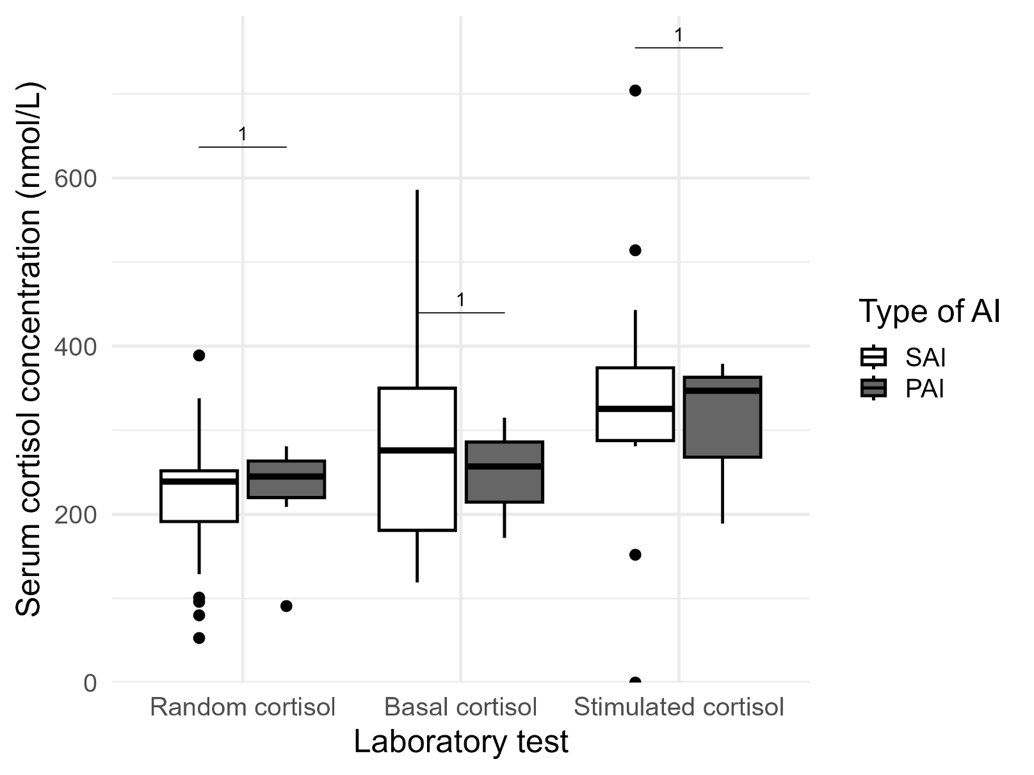
Figure 2: Comparison of cortisol concentrations for SAI versus PAI using the 400 nmol/L cut-off
Apart from ACTH concentrations; p<0.001 there were nodifferences in demographics, history, clinical findings, investigations and mortality in SAI, compared with PAI.

Mortality in the subgroup of patients with AI versus without AI
Cryptococcal neoformans associated mortality was greater in the AI than in the non-AI groups, 60.0% vs 5.7%; p<0.028. Despite the Kaplan-Meier analyses showing no difference in survival for the entire follow-up period, when comparing survival at 3 months, 6 months and 12 months, AI patients had relatively better survival at 12 months, compared with those patients without AI; p=0.0371. What about those on treatment versus those off, please treatment?
Predictors of mortality:
Accelerated mortality was associated with increased skin pigmentation,, poor appetite, raised random serum cortisol and plasma ACTH. Patients with a self-reported increase in skin pigmentation had a 51% increase in the odds of death [OR = 1.51 (95%CI: 1.03, 2.22)]; p=0.033, but this was not exclusively due to primary hypoadrenalism. Poor appetite was associated with a 77% likelihood of premature death [OR=1.77 (95%CI: 1.11, 2.90)]; p=0.020. Opiate use was associated with a 44.5% reduction in the odds of mortality [aOR = 0.555 (95%CI:0.33, 0.933)]; p=0.026. . (Table 5). For every 50 nmol/L increase in the basal serum cortisol, there was an associated 14% increase in the likelihood of death within 12 months [OR = 1.14, (95% CI:1.08, 1.21)]; p<0.001.. For every 100 pg/L increase in the plasma ACTH, there was a 117% increase in odds of death [OR = 2.17, (95%CI:1.35, 3.72)]; p<0.003.
After adjusting for several factors, as shown in Table 4, a decrease in systolic, but increased diastolic blood pressures, increased random cortisol and opiate use were independently associated with premature mortality. A 10 mmHg increase in diastolic blood pressure was associated with a 30% increase in likelihood of premature mortality [aOR = 1.30 (95%CI: 1.07, 1.59)]; p=0.010). Every 10 mmHg increase in systolic blood pressure was associated with an 18% reduction in the odds of mortality [aOR = 0.82 (95%CI: 0.71, 0.95)]; p=0.010. Every 50 nmol/L increase in random cortisol was associated with a 14.7% likelihood of premature death [aOR = 1.147 (95%CI:1.082, 1.217)]; p<0.001.

Artificial Intelligence Prediction of Adrenal Insufficiency
The best-performing model demonstrated excellent predictive capability on the unseen test data. Evaluation of its performance yielded a sensitivity of 100% and a specificity of 80.4%, indicating the model’s strong ability to correctly identify patients with AI, with an overall accuracy of 80.5%. The confusion matrix for this model, presented in Figure 3, illustrates that it correctly classified 1 of the 1 patients with AI in the test set.

The overall discriminative power of the model was further quantified using its Receiver Operating Characteristic (ROC) curve (Figure 4), yielding an Area Under the Curve (AUC) of 0.812.

To minimise bias arising from reliance on a single model and to account for variability introduced by multiple imputation, feature importance estimates were aggregated across ensemble models within each imputed dataset and subsequently pooled. The resulting distribution of predictor importance (Figure 5) demonstrates a broadly distributed profile, with no single variable overwhelmingly dominating model performance, although clear leading contributors are evident.

Haemoglobin (20.5%) and incremental cortisol (15.5%) consistently emerged as the primary driving predictors of model performance. Despite their prominence, these factors were complemented by a tier of intermediate variables, including an alternative aetiology of anaemia (10.5%), a past history of tuberculosis (8.0%), and use of anti-tuberculosis medication (6.5%), underscoring the multifactorial and systemic clinical presentation of these patients.

Demographic and specific clinical signs contributed moderately to the ensemble; with age at enrolment (5.0%), the use of gastrointestinal antiemetics (4.8%), loss of axillary and pubic hair in female patients (4.7%), male gender (4.5%), and active diarrhoea (4.0%). A final cluster of constitutional symptoms, laboratory markers, and treatment factors maintained small but consistent contributions, led by poor appetite (3.9%), white cell count (3.8%), current tuberculosis status (3.7%), rifampicin therapy (3.6%), and HIV viral load (3.5%). Notably, several predictors, particularly haemoglobin and incremental cortisol, showed relatively wide uncertainty intervals, reflecting variations across the imputed datasets and neural network training runs.

Physiological markers for example, haemoglobin and incremental cortisol were leading predictors across iterations supporting their biological robustness. We think there is value of incorporating a broad range of clinical, laboratory, and treatment-related variables in multivariable models to adequately capture the complexity of AI risk.

Discussion:

In our study of HIV positive patients with a CD4 count less than 100 cells/mm³ and an OI, the prevalence of AI was 6.22%. In the entire cohort of patients, the group with the lowest CD4 counts were younger and the remaining CD4 tertiles. Cryptococcal infection occurred more often among patients who were HAART naïve compared with those on HAART. Patients with AI had comparatively lower heart rates, higher incidence of extrapulmonary TB, cryptococcal infection, raised haemoglobin and paradoxically relatively increased serum sodium concentration. SAI, compared to PAI predominated in a 4:1 ratio. Cryptococcal neoformans infection, lower random, basal, stimulated and incremental cortisol concentrations were associated with higher mortality in the AI group. Increased skin pigmentation, poor appetite, raised cortisol and ACTH concentrations were associated with increased mortality at 12 months after admission to hospital. The twelve-month mortality for the entire group was 26.9%. Independent factors predictive for mortality in this cohort were a decrease in systolic and an increase in diastolic blood pressure, and elevated random cortisol. Patients with AI had relatively better survival at 12 months, compared to those without AI. The best performing artificial intelligence model was able to correctly identify patients with AI in our cohort group with 100.0% sensitivity and 80.5% specificity. Besides incremental cortisol, haemoglobin, anaemia & past TB contributed significantly to correctly identifying AI.

HIV impedes normal immunity by directly infecting and eliminating CD4 cells in inadequately-treated patients [22] (22). Patients with a CD4 count less than 100 cells/mm³ represent profoundly immunosuppression predisposed to life-threatening (OI’s) and malignancies and require HAART to favourably alter their prognoses (reference).

Although we found a prevalence of AI in our cohort of 6.22%, using the 250 µg tetracosactide test and a stimulated cortisol cutoff of 400 nmol/L and a random cortisol of less than 274 nmol/L, it may have been over-estimated due to the applied cut-offs. When using the stimulated cut-off points of 400 nmol/L and 240 nmol/L, the reported prevalences would have been 2.49% and 1.95%, respectively. Various reported prevalences of AI exist in patients with HIV ranging from 5.4% in a USA study by Membreno et al, using a 250µg tetracosactide stimulated cortisol cutoff of 687 nmol/L [23], to 19.2% in a small study of 26 patients in India [24], and 24% [25] to 33.3% in Nigeria, using the 1 µg stimulation and 504 nmol/L cortisol cutoff [26]. Additionally, it was found that 34.8% had AI, using a 1 µg stimulation test and a cut-off of a stimulated cortisol of 380.2 nmol/L and an incremental cortisol less than 158.5 nmol/L [14]. Various prevalences of AI among HIV-positive patients are attributable to bias arising from small study sizes and diverse cut-offs for cortisol. We cannot advocate for routine exclusion of AI among HIV-positive patients, despite prior recommendations [24]. Screening for AI in advanced HIV should be reserved for very high-risk cases.

Patients in the lowest CD4 tertile, were younger, reflecting that they may be less predisposed to being tested for HIV or exhibit a delay in initiation of antiretroviral therapy [27]. Younger patients may underestimate their risk of testing positive due to perceived good health [28], they may also fear positive results and the mandatory incumbent-associated lifestyle changes necessary with a positive result, stigma and discrimination within communities, and perceived concerns about the maintenance of confidentiality of their HIV results [29]. Very low CD4 counts if using antiretroviral therapy may be due to antiretroviral resistance, HIV mutations, poor compliance or simultaneous multiple HIV strain coinfection (superinfection), thought to be rare among younger individuals [30]. As expected, the subgroup with the lowest CD4 counts also had the highest viral loads and associated leukopaenia, lymphopaenia, neutropaenia relative to the groups with higher CD4 counts.

The heart rate among AI was relatively slower compared with non-AI patients, which was also reported in the original description of Addison’s disease, potentially due to increased vagal tone [31]. AI in our cohort was associated with a higher incidence of extrapulmonary TB and cryptoccocal infections. Extrapulmonary TB may be aetiological in the development of AI due to its predilection for infiltration of the adrenal glands and paradoxically, rifampicin the mainstay for the treatment of TB accelerates cortisol metabolism through induction of cytochrome P-450-3A4. [32] Similarly, disseminated cryptococcal infection may induce PAI through direct infiltration of the adrenal glands [33] and its incumbent therapy, fluconazole may result in AI through inhibiting steroidogenesis [34] [35].

We also observed a relatively higher haemoglobin concentration among patients with AI, in contradistinction to the usual expecting findings of normochromic normocytic anaemia [36, 37], which is likely explained by hemoconcentration, associated with dehydration due to excess vomiting and/ or diarrhoea, from a myriad of causes in HIV. [38, 39]. Additionally, we found curiously that a subset of patients with AI had relative higher serum sodium concentrations. Potential explanations for this association may include contraction of the intravascular volume due to vomiting from a range of causes including HAART therapy or HIV associated opportunistic infections of the gut, leading to diarrhoea with inadequate water intake to match the losses [40](43).

SAI appears to occur more commonly than PAI among patients with advanced HIV, possibly due to elevated concentrations of proinflammatory circulating cytokines. Proinflammatory cytokines have the potential to directly suppress CRH and ACTH, which may be reversible. [41].

The association between Cryptococcus neoformans and mortality in HIV is well described, with Rajasingham et al, reporting that 75% of the cryptococcal meningitis deaths occur in sub-Saharan Africa [42], We have observed an association of cryptococcal infection and mortality in patients with AI. Despite initiating hydrocortisone replacement therapy, mortality was higher than the background of HIV positive patients suggesting that they may have died from an adrenal crisis, or that the combination of AI, HIV and cryptococcus represented overwhelming insults [43].

Chronic stress and elevated cortisol have been associated with increased ICU mortality [44, 45]. The association of mortality with lower random, basal, stimulated and incremental cortisol [46] concentrations in AI are consistent with a U-shaped association of cortisol with mortality.

Patients with AI had relatively better survival at 12 months following admission to hospital, compared to those without AI. Potential explanations for this may have been better clinical surveillance and prompt recognition and treatment of their OI at their follow-up visits. On the other hand, we cannot suggest a survival advantage by having AI, when the literature is awash with accelerated mortality [47].

The diagnosis of AI is often made on non-specific grounds, making its discrimination from other conditions in severely ill patients challenging. We have successfully developed and validated the first neural network model of its kind for this purpose, which demonstrated the ability to predict AI with 100.0% sensitivity and 80.5% specificity. Our findings confirm the central clinical role of cortisol concentrations in diagnosis, but other features, for example anaemia, past TB and use of anti-TB treatment. This machine learning model represents a promising step towards creating a reliable, data-driven tool to assist clinicians in the early identification of patients at high risk for AI in the context of HIV.

The strength of the study lies in its large size, a systematic approach to evaluating all patients for AI and follow-up to determine survival. As with all large studies there were missing data. For example, it could be considered a detraction that all patients with a random cortisol concentration less than 400 nmol/L did not undergo a tetracosactide test. It should also be recognised that our findings are not transferable to HIV positive patients with higher CD4 counts and absence of OI. Additionally, if the cortisol cut-off was over 400 nmol/L, 26% of the cases would have been incorrectly diagnosed with AI. This may represent a limitation of the assay, with a tendency to over-diagnose cases.

Conclusion
This large, advanced HIV study revealed a significant risk of AI varying between 2% and 4%, depending on the chosen stimulated cortisol cut off points, and validated diagnostic criteria. Cryptococcal infection was associated with an increased risk of AI and mortality. Artificial intelligence offers the promise of accurate prediction of HIV-associated AI.

References

1. Dunlop, D., Eight-six cases of Addison's disease. British medical journal, 1963. 2(5362): p. 887.
2. Betterle, C. and L. Morlin, Autoimmune Addison’s disease, in Pediatric Adrenal Diseases. 2011, Karger Publishers. p. 161–172.
3. Ross, I.L. and N.S. Levitt, Addison's disease symptoms--a cross sectional study in urban South Africa. PLoS One, 2013. 8(1): p. e53526.
4. Mofokeng, T.R., et al., Significant barriers to diagnosis and management of adrenal insufficiency in Africa. Endocrine connections, 2020. 9(5): p. 445–456.
5. Mofokeng, T.R.P., et al., Tiered healthcare in South Africa exposes deficiencies in management and more patients with infectious etiology of primary adrenal insufficiency. PLoS One, 2020. 15(11): p. e0241845.
6. Goliber, T., The status of the HIV/AIDS epidemic in Sub-Saharan Africa. Population Reference Bureau, 2002.
7. Hofbauer, L.C. and A.E. Heufelder, Endocrine implications of human immunodeficiency virus infection. Medicine, 1996. 75(5): p. 262–278.
8. Boulle, A., et al., Mortality in patients with HIV-1 infection starting antiretroviral therapy in South Africa, Europe, or North America: a collaborative analysis of prospective studies. PLoS medicine, 2014. 11(9): p. e1001718.
9. Arlt, W., Adrenal insufficiency. Clinical medicine, 2008. 8(2): p. 211.
10. Husebye, E.S., et al., Adrenal insufficiency. The Lancet, 2021. 397(10274): p. 613–629.
11. Eledrisi, M.S. and A.C. Verghese, Adrenal insufficiency in HIV infection: a review and recommendations. The American journal of the medical sciences, 2001. 321(2): p. 137–144.
12. Bornstein, S.R., Predisposing factors for adrenal insufficiency. New England Journal of Medicine, 2009. 360(22): p. 2328–2339.
13. Afreen, B., K.A. Khan, and A. Riaz, Adrenal insufficiency in Pakistani HIV infected patients. Journal of Ayub Medical College Abbottabad, 2017. 29(3): p. 428–431.
14. Odeniyi, I., et al., Adrenocortical function in Nigerians with human immunodeficiency virus infection. Ghana Medical Journal, 2013. 47(4): p. 171.
15. Sharma, N., et al., Presence, patterns & predictors of hypocortisolism in patients with HIV infection in India. Indian Journal of Medical Research, 2018. 147(2): p. 142–150.
16. Bergthorsdottir, R., et al., Premature mortality in patients with Addison’s disease: a population-based study. The Journal of Clinical Endocrinology & Metabolism, 2006. 91(12): p. 4849–4853.
17. Johannsson, G., et al., Adrenal insufficiency: review of clinical outcomes with current glucocorticoid replacement therapy. Clinical endocrinology, 2015. 82(1): p. 2–11.
18. Tchouakak, A., HIV progress raises life expectancy in Africa–UN. SciDev. net-Health, 2024.
19. Druce, I., et al., Routine screening for central and primary adrenal insufficiency during immune-checkpoint inhibitor therapy: an endocrinology perspective for oncologists. Current Oncology, 2022. 29(7): p. 4665–4677.
20. Holst, J.P., et al., Use of steroid profiles in determining the cause of adrenal insufficiency. Steroids, 2007. 72(1): p. 71–84.
21. Vogeser, M., et al., Multicenter performance evaluation of a second generation cortisol assay. Clinical Chemistry and Laboratory Medicine (CCLM), 2017. 55(6): p. 826–835.
22. Février, M., K. Dorgham, and A. Rebollo, CD4+ T cell depletion in human immunodeficiency virus (HIV) infection: role of apoptosis. Viruses, 2011. 3(5): p. 586.
23. Membreno, L., et al., Adrenocortical function in acquired immunodeficiency syndrome. The Journal of Clinical Endocrinology & Metabolism, 1987. 65(3): p. 482–487.
24. Prasanthai, V., et al., Prevalence of adrenal insufficiency in critically ill patients with AIDS. JOURNAL-MEDICAL ASSOCIATION OF THAILAND, 2007. 90(9): p. 1768.
25. Bhatia, E., Adrenal disorders in people with HIV: The highs and lows. Indian Journal of Medical Research, 2018. 147(2): p. 125–127.
26. Hassan, A., et al., Prevalence of Adrenocortical Insufficiency in Treatment-Naïve HIV Patients in Maiduguri: A Cross-Sectional Study. Sch J Med Case Rep, 2025. 8: p. 1914–1919.
27. Ahmed, S.I., et al., Attitudes and barriers towards HIV screening: A qualitative study of people living with HIV/AIDS (PLWHA) in Malaysia. Journal of Infection Prevention, 2017. 18(5): p. 242–247.
28. Peralta, L., et al., Barriers and facilitators to adolescent HIV testing. AIDS patient care and STDs, 2007. 21(6): p. 400–408.
29. Katirayi, L., et al., Understanding gender differences of people with HIV newly diagnosed or returning to care with advanced HIV disease in Malawi: a qualitative study. BMC Public Health, 2023. 23.
30. Redd, A.D., et al., The rates of HIV superinfection and primary HIV incidence in a general population in Rakai, Uganda. The Journal of infectious diseases, 2012. 206(2): p. 267–274.
31. Zaloga, G.P. and P. Marik, Hypothalamic-pituitary-adrenal insufficiency. Critical care clinics, 2001. 17(1): p. 25–41.
32. Elansary, E. and J. Earis, Rifampicin and adrenal crisis. British Medical Journal (Clinical research ed.), 1983. 286(6381): p. 1861.
33. Ito, M., et al., Disseminated cryptococcosis with adrenal insufficiency and meningitis in an immunocompetent individual. Internal Medicine, 2017. 56(10): p. 1259–1264.
34. Paolo Jr, W.F. and J.D. Nosanchuk, Adrenal infections. International journal of infectious diseases, 2006. 10(5): p. 343–353.
35. Pont, A., et al., Ketoconazole blocks adrenal steroid synthesis. Annals of internal medicine, 1982. 97(3): p. 370–372.
36. Oelkers, W., Adrenal insufficiency. N Engl J Med, 1996. 335(16): p. 1206–12.
37. Alexandraki, K.I. and A. Grossman, Diagnosis and management of adrenal insufficiency. Endotext [Internet], 2018.
38. Rushworth, R.L. and D.J. Torpy, A descriptive study of adrenal crises in adults with adrenal insufficiency: increased risk with age and in those with bacterial infections. BMC endocrine disorders, 2014. 14(1): p. 79.
39. Lousada, L.M., B.B. Mendonca, and T.A. Bachega, Adrenal crisis and mortality rate in adrenal insufficiency and congenital adrenal hyperplasia. Archives of Endocrinology and Metabolism, 2021. 65(4): p. 488–494.
40. Hariram, T., K. Naidoo, and S. Ramji, Hypernatraemic dehydration in infants with acute gastroenteritis at King Edward VIII Hospital, Durban, South Africa. South African Journal of Child Health, 2018. 12(1): p. 10–14.
41. Donegan, D. and I. Bancos. Opioid-induced adrenal insufficiency. in Mayo Clinic Proceedings. 2018. Elsevier.
42. Rajasingham, R., et al., Global burden of disease of HIV-associated cryptococcal meningitis: an updated analysis. The Lancet infectious diseases, 2017. 17(8): p. 873–881.
43. Chaka, W., et al., Presentation and outcome of suspected sepsis in a high-HIV burden, high antiretroviral coverage setting. International Journal of Infectious Diseases, 2020. 96: p. 276–283.
44. Van den Berghe, G., Adrenal function/dysfunction in critically ill patients: a concise narrative review of recent novel insights. Journal of anesthesia, 2021. 35(6): p. 903–910.
45. Christ-Crain, M., et al., Free and total cortisol levels as predictors of severity and outcome in community-acquired pneumonia. American journal of respiratory and critical care medicine, 2007. 176(9): p. 913–920.
46. Maqbool, M., et al., Prevalence of occult adrenal insufficiency and the prognostic value of a short corticotropin stimulation test in patients with septic shock. Indian Journal of Critical Care Medicine: Peer-reviewed, Official Publication of Indian Society of Critical Care Medicine, 2009. 13(2): p. 85.
47. Ngaosuwan, K., et al., Increased mortality risk in patients with primary and secondary adrenal insufficiency. The Journal of Clinical Endocrinology & Metabolism, 2021. 106(7): p. e2759–e2768.

24 AI by Random Cortisol < 274 nmol/L
Recruited (N=589): HIV-positive adults with CD4 count <100 cells/mm³ and at least one opportunistic infection.
Excluded (N=26):
No consent & Incomplete data
Topical steroids use
Enrolled (N=563)
Excluded Adrenal Insufficiency (Non-AI) (N=507)

Confirmed Adrenal Insufficiency (AI) (N=56)
AI by stimulated Cortisol
32 using < 500, nmol/L
14 using < 400 nmol/L,
2 using < 240 nmol/L

Figure 1: Consort flow diagram of patient enrollment

Table 1: Patient presentation by CD4 count in tertiles with the p-values comparing patient clinical characteristics on admission across the tertiles
Variable | Overall,  N = 558¹ | 0 - 33,  N = 278¹ | 34 - 66,  N = 156¹ | 67 - 100,  N = 124¹ | p-value²
Age at enrolment, median (IQR) (years) | 36.0 (31.0, 43.0) | 35.0 (30.0, 42.0) | 37.0 (32.0, 44.0) | 38.0 (33.0, 46.0) | 0.003
Gender, N (%) |  |  |  |  | 0.2
Female | 282 (50.6%) | 139 (50.0%) | 87 (55.8%) | 56 (45.5%)
Duration of current illness, median (IQR) (days) | 14.0 (12.0, 21.0) | 14.0 (14.0, 21.0) | 14.0 (11.5, 21.0) | 14.0 (7.0, 21.0) | 0.067
Weight loss | 465 (86.4%) | 236 (87.1%) | 133 (87.5%) | 96 (83.5%) | 0.6
HIV log10 viral load | 10.7 (7.3, 12.4) | 11.6 (9.3, 12.8) | 8.9 (6.3, 12.3) | 7.6 (3.9, 10.3) | <0.001
Opportunistic infections
Tuberculosis | 459 (84.4%) | 229 (84.5%) | 131 (86.2%) | 99 (81.8%) | 0.6
Pneumonia | 62 (11.4%) | 30 (11.1%) | 19 (12.5%) | 13 (10.7%) | 0.9
Candida albicans | 35 (6.4%) | 22 (8.1%) | 11 (7.2%) | 2 (1.7%) | 0.049
Cryptococcus neoformans | 29 (5.3%) | 15 (5.5%) | 5 (3.3%) | 9 (7.4%) | 0.3
Gastroenteritis | 23 (4.2%) | 12 (4.4%) | 7 (4.6%) | 4 (3.3%) | 0.8
Hepatitis B | 18 (3.3%) | 9 (3.3%) | 8 (5.3%) | 1 (0.8%) | 0.12
Syphilis | 17 (3.1%) | 8 (3.0%) | 8 (5.3%) | 1 (0.8%) | 0.11
Kaposis sarcoma | 6 (1.1%) | 6 (2.2%) | 0 (0.0%) | 0 (0.0%) | 0.056
Urinary tract infection | 7 (1.3%) | 4 (1.5%) | 0 (0.0%) | 3 (2.5%) | 0.2
Pneumocystis Jiroveci Pneumonia | 5 (0.9%) | 4 (1.5%) | 1 (0.7%) | 0 (0.0%) | 0.5
Herpes simplex virus | 8 (1.5%) | 3 (1.1%) | 4 (2.6%) | 1 (0.8%) | 0.4
Bacterial meningitis | 6 (1.1%) | 3 (1.1%) | 1 (0.7%) | 2 (1.7%) | 0.8
Haematological parameters
White cell count x10⁹/L | 5.4 (3.7, 8.2) | 5.1 (3.0, 7.4) | 5.7 (4.2, 8.6) | 6.9 (4.5, 9.9) | <0.001
Lymphocyte count x10⁹/L | 0.8 (0.4, 1.8) | 0.6 (0.3, 1.3) | 0.9 (0.5, 4.9) | 1.3 (0.8, 2.9) | 0.004
Neutrophils x10⁹/L | 3.4 (1.5, 8.5) | 2.4 (1.1, 6.2) | 6.6 (1.9, 15.2) | 5.2 (3.1, 11.3) | 0.003
Medical history
HAART exposure | 204 (36.6%) | 100 (36.0%) | 61 (39.1%) | 43 (34.7%) | 0.7
Anti-tuberculous therapy | 13 (2.3%) | 5 (1.8%) | 3 (1.9%) | 5 (4.0%) | 0.4
Antifungal therapy | 6 (1.1%) | 2 (0.7%) | 1 (0.6%) | 3 (2.4%) | 0.3
¹Median (IQR); ²Wilcoxon rank sum test; Pearson's Chi-squared test; Fisher's exact test IQR-interquartile range, TB-tuberculosis, HAART Highly active antiretroviral therapy
^{p} -value is a simultaneous comparison of all the clinical characteristics by CD4 count tertiles.

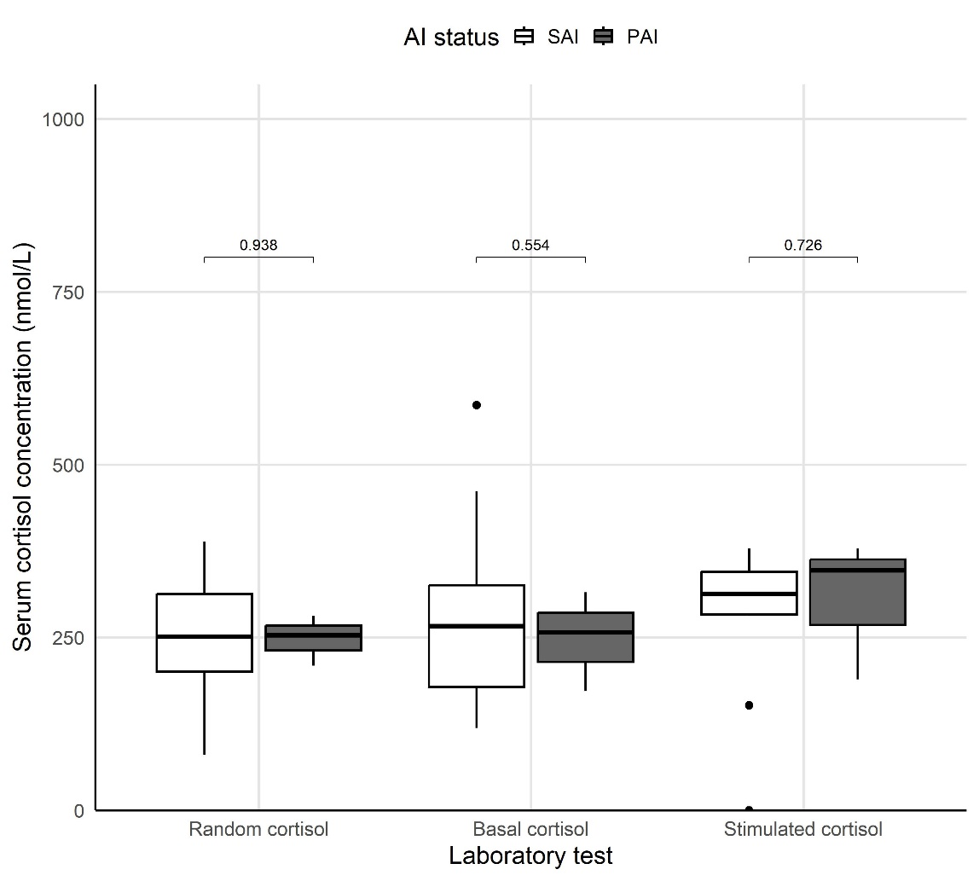

Figure 2a: Boxplot PAI and SAI without ACTH

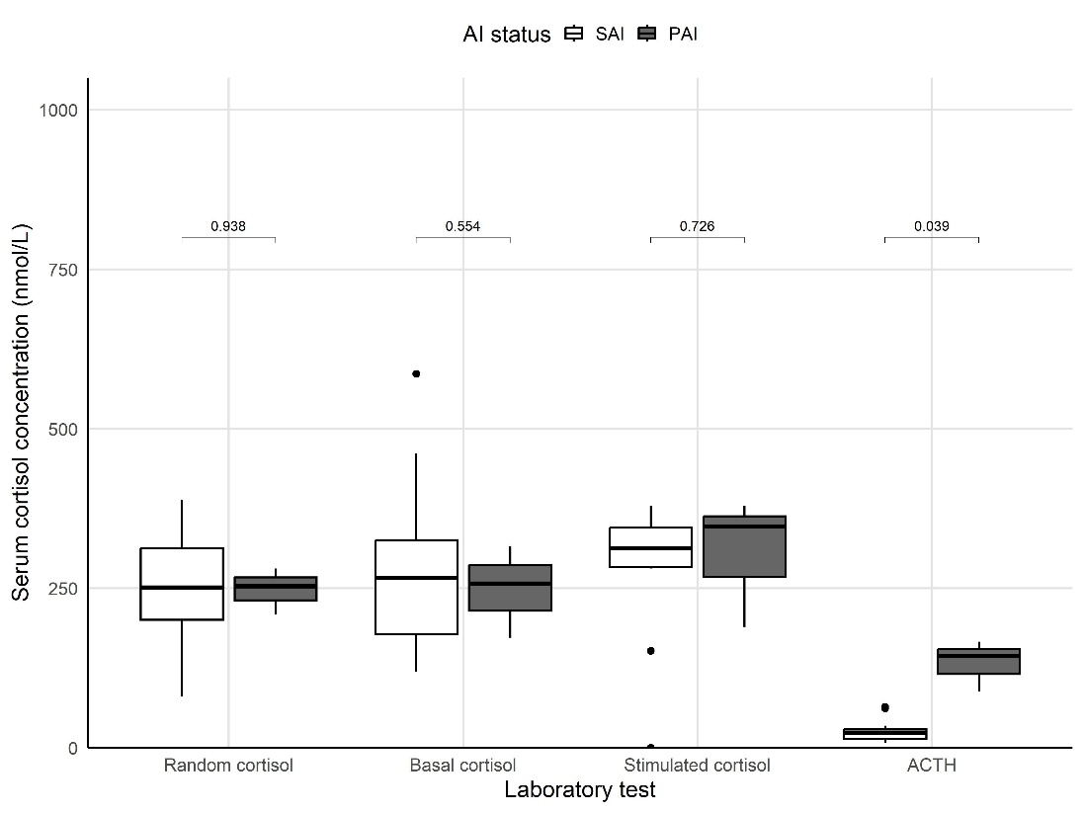
Figure 2b: Boxplot PAI and SAI with ACTH

Table 2: Comparison of clinical characteristics in patients with adrenal insufficiency with those without
Variable | Non-AI, N = 549¹ | AI, N = 14¹ | p- value²
Age at enrolment, median (IQR) (years) | 36.0 (31.0, 43.0) | 44.5 (33.0, 50.0) | 0.3
Female gender, N (%) | 275 (50.2%) | 9 (64.3%) | 0.8
Duration of current illness, median (IQR) (days) | 14.0 (11.5, 21.0) | 14.0 (7.0, 30.0) | 0.9
HISTORY
Weight loss | 454 (86%) | 11 (79%) | 0.9
Weakness | 447 (85%) | 11 (79%) | 0.9
Tiredness | 450 (86%) | 11 (79%) | 0.9
Poor appetite | 398 (76%) | 12 (86%) | 0.9
Increased pigmentation of the skin | 261 (51%) | 3 (25%) | 0.5
Nausea | 282 (54%) | 7 (50%) | >0.9
Vomiting | 146 (28%) | 5 (36%) | 0.9
Liking for salt | 274 (52%) | 10 (71%) | 0.7
Hypoglycaemia | 11 (2.1%) | 0 (0%) | >0.9
Loss of consciousness | 7 (1.3%) | 0 (0%) | >0.9
Diarrhoea | 232 (45%) | 5 (36%) | 0.9
Dizziness | 255 (49%) | 5 (38%) | 0.9
Shock | 5 (1.0%) | 0 (0%) | >0.9
Anorexia | 251 (48%) | 2 (14%) | 0.2
Loss of axillary and pubic hair, if female | 101 (38%) | 1 (10%) | 0.5
CLINICAL FEATURES
BP (diastolic) mmHg | 70.0 (60.0, 79.0) | 71.5 (60.0, 80.0) | 0.9
Heart rate beats per minute | 90.5 (78.0, 109.0) | 85.0 (77.0, 93.0) | 0.8
Hypotension | 49 (9.4%) | 0 (0.0%) | >0.9
Any postural drop in blood pressure | 23 (4.4%) | 0 (0.0%) | >0.9
Presence of anaemia | 314 (60.4%) | 6 (42.9%) | 0.7
INVESTIGATIONS
Viral load (log10 copies/mL) | 4.7 (3.2, 5.4) | 5.3 (5.3, 5.3) | 0.9
Pulmonary tuberculosis | 341 (63.7%) | 7 (50.0%) | 0.8
Extra pulmonary tuberculosis | 107 (20.0%) | 3 (21.4%) | >0.9
Cryptococcus neoformans | 23 (4.3%) | 6 (42.9%) | 0.001
Pneumonia | 60 (11.2%) | 2 (14.3%) | >0.9
Hepatitis B | 16 (3.0%) | 2 (14.3%) | 0.5
Candida albicans | 34 (6.4%) | 1 (7.1%) | >0.9
Kaposis sarcoma | 6 (1.1%) | 0 (0.0%) | >0.9
Pneumocystis Jiroveci Pneumonia | 5 (0.9%) | 0 (0.0%) | >0.9
Herpes simplex virus | 8 (1.5%) | 0 (0.0%) | >0.9
Gastroenteritis | 23 (4.3%) | 0 (0.0%) | >0.9
Total CD4 count | 34.0 (14.0, 63.0) | 36.5 (15.0, 51.0) | >0.9
White cell count x10⁹/L | 5.6 (3.7, 8.2) | 4.1 (3.3, 6.5) | 0.9
Lymphocyte count x10⁹/L | 0.8 (0.4, 2.0) | 0.4 (0.4, 0.5) | 0.8
Neutrophils x10⁹/L | 3.6 (1.5, 8.9) | 1.3 (1.0, 1.7) | 0.7
Sodium mmol/L | 133.0 (130.0, 137.0) | 136.0 (133.0, 139.0) | 0.6
Potassium mmol/L | 4.1 (3.6, 4.6) | 3.5 (3.3, 4.0) | 0.2
Haemoglobin g/dL | 8.7 (7.4, 10.3) | 8.7 (7.9, 10.3) | >0.9
MANAGEMENT & OUTCOMES
Mortality | 162 (68%) | 5 (71%) | >0.9
Fluconazole | 69 (13%) | 5 (36%) | 0.3
Opiates | 121 (22%) | 5 (36%) | 0.9
HAART exposure | 199 (36%) | 5 (36%) | >0.9
¹Median (IQR); N (%); ²Wilcoxon rank sum test; Pearson’s Chi-squared test; Wilcoxon rank sum exact test; Fisher’s exact test

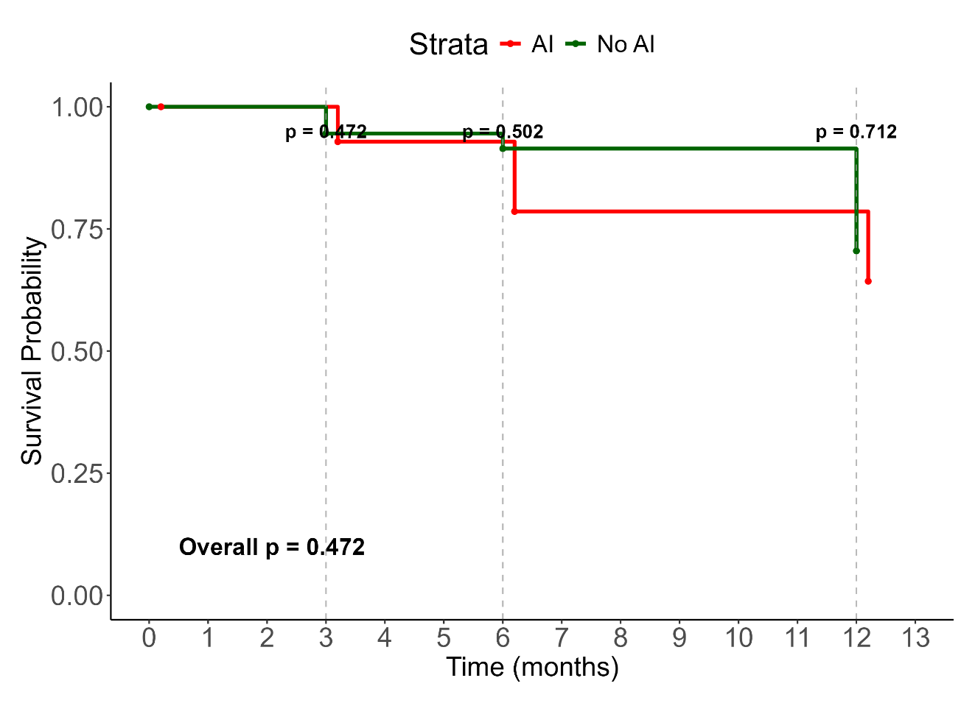
Figure 2: The Kaplan-Meier survival curves for patients with adrenal insufficiency (AI) compared with those without (No-AI) in HIV-positive patients with a CD4 count less than 100 cells per mm³

p-values at 3-months, 6-months, 12-months

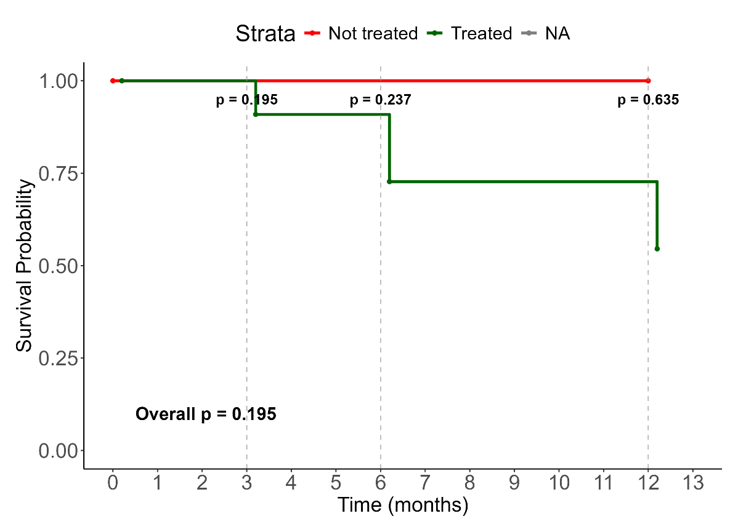

Figure 3: Kaplan meier for treated vs untreated

Table 3: Comparisons of the clinical characteristics of patients who died with AI versus those without
Variable | AI, N = 5¹ | Non-AI, N = 387¹ | p-value²
Age at enrolment, median (IQR)  (years) | 47.0 (42.0, 48.0) | 36.0 (31.0, 43.0) | 0.5
Female gender, N(%) | 4 (80.0%) | 190 (49.2%) | 0.8
Duration of current illness, median  (IQR) (days) | 10.5 (7.0, 37.0) | 14.0 (10.0, 21.0) | >0.9
HISTORY
Weight loss | 4 (80%) | 320 (85%) | >0.9
Weakness | 5 (100%) | 316 (85%) | >0.9
Tiredness | 5 (100%) | 316 (84%) | >0.9
Poor appetite | 5 (100%) | 273 (74%) | 0.9
Increased pigmentation of the skin | 1 (25%) | 175 (48%) | >0.9
Nausea | 3 (60%) | 192 (51%) | >0.9
Loss of consciousness | 0 (0%) | 3 (0.8%) | >0.9
Diarrhea | 1 (20%) | 159 (43%) | 0.9
Dizziness | 1 (20%) | 178 (48%) | 0.9
Shock | 0 (0%) | 3 (0.8%) | >0.9
Anorexia | 1 (20%) | 175 (47%) | 0.9
Loss of axillary and pubic hair, if  female | 1 (25%) | 65 (35%) | >0.9
CLINICAL FEATURES
BP (systolic) mmHg | 120.0 (120.0, 130.0) | 112.0 (104.0, 126.0) | 0.9
BP (diastolic) mmHg | 63.0 (60.0, 80.0) | 70.0 (60.0, 76.0) | >0.9
Heart rate beats per minute | 82.0 (65.0, 92.0) | 90.0 (79.0, 110.0) | 0.9
Hypotension | 0 (0.0%) | 33 (8.9%) | >0.9
Any postural drop in blood pressure | 0 (0.0%) | 16 (4.3%) | >0.9
Presence of anaemia | 2 (40.0%) | 217 (58.6%) | >0.9
INVESTIGATIONS
Sodium mmol/L | 139.0 (133.0, 139.0) | 134.0 (130.0, 137.0) | 0.7
Potassium mmol/L | 3.8 (3.7, 4.0) | 4.1 (3.7, 4.6) | 0.6
Haemoglobin g/dL | 8.7 (8.1, 10.2) | 8.9 (7.5, 10.6) | >0.9
Syphilis | 0 (0.0%) | 14 (3.7%) | >0.9
Candida | 0 (0.0%) | 26 (6.9%) | >0.9
Hepatitis B | 1 (20.0%) | 11 (2.9%) | 0.6
Herpes simplex virus HSV | 0 (0.0%) | 6 (1.6%) | >0.9
Pneumonia | 0 (0.0%) | 46 (12.2%) | >0.9
Pneumocystis Jiroveci Pneumonia | 0 (0.0%) | 3 (0.8%) | >0.9
Pulmonary tuberculosis | 2 (40.0%) | 237 (62.9%) | 0.9
Extrapulmonary tuberculosis | 1 (20.0%) | 76 (20.2%) | >0.9
Cryptococcus neoformans | 3 (60.0%) | 14 (3.7%) | 0.009
Total CD4 count cells/ mm3 | 17.0 (15.0, 43.0) | 35.0 (15.0, 65.0) | >0.9
Viral load (log10 copies/mL) | NA (NA, NA) | 10.3 (6.3, 12.2)
Random cortisol nmol/L | 251.0 (237.0, 281.0) | 444.0 (349.0, 553.0) | 0.017
Basal cortisol nmol/L | 266.0 (228.0, 301.0) | 412.0 (302.0, 559.0) | 0.063
Stimulated cortisol nmol/L | 316.0 (296.0, 335.0) | 698.0 (576.5, 811.0) | 0.008
Absolute delta cortisol | 30.0 (17.0, 32.0) | 276.0 (178.0, 380.0) | 0.008
Percentage change in cortisol levels* | 10.2 (9.9, 11.3) | 68.1 (34.4, 119.8) | 0.026
¹Median (IQR); N (%); ²Wilcoxon rank sum test; Pearson’s Chi-squared test; Wilcoxon rank sum exact test; Fisher’s exact test
*Difference in the basal, compared to the stimulated cortisol, expressed as a percentage basal cortisol p-value is a comparison of clinical characteristics of patients with AI versus those without AI, among all those who had died

Table 4: Bivariate and Multivariate analysis of factors associated with time to mortality of patients in the entire cohort.

Characteristic | Bivariate |  |  |  | Multivariable (Pooled)
 | N | OR¹ | 95% CI² | p-value | Adj. OR³ | 95% CI² | p-value
History
Increased skin pigmentation | 525 | 1.51 | 1.03, 2.22 | 0.033 | 1.36 | 0.87, 2.14 | 0.176
Poor appetite | 535 | 1.77 | 1.11, 2.90 | 0.020 | 1.18 | 0.68, 2.06 | 0.550
Liking for salt | 536 | 1.33 | 0.92, 1.95 | 0.133
Nausea | 538 | 1.40 | 0.96, 2.05 | 0.080
Systolic Blood Pressure | 553 | 0.93 | 0.84, 1.03 | 0.181
Diastolic Blood Pressure | 553 | 1.13 | 0.98, 1.30 | 0.088
Investigations
Haemoglobin (Drop) | 558 | 0.92 | 0.85, 1.00 | 0.060
Clostridium difficile | 549 | 0.49 | 0.14, 1.32 | 0.196
Increased Random cortisol | 548 | 1.14 | 1.08, 1.21 | <0.001 | 1.15 | 1.08, 1.22 | <0.001
Basal_cortisol | 167 | 1.06 | 0.98, 1.15 | 0.134
Increased ACTH | 548 | 2.17 | 1.35, 3.72 | 0.003 | 1.55 | 0.90, 2.67 | 0.112
Cryptococcus neoformans | 549 | 1.72 | 0.79, 3.67 | 0.161 | 1.58 | 0.63, 3.97 | 0.331
Pneumonia | 549 | 0.66 | 0.34, 1.21 | 0.196 | 0.59 | 0.26, 1.32 | 0.196
CD4 count | 557 | 0.77 | 0.56, 1.06 | 0.113
Viral load | 126 | 1.08 | 0.98, 1.21 | 0.142
Medications
Opiate use | 563 | 0.55 | 0.33, 0.87 | 0.013 | 0.54 | 0.32, 0.89 | 0.016
Fluconazole | 563 | 1.64 | 0.98, 2.71 | 0.056 | 1.68 | 0.96, 2.94 | 0.070
Addissons disease | 563 | 1.33 | 0.40, 3.90 | 0.651 | 2.15 | 0.60, 7.69 | 0.239
¹Odds Ratio; ²95% Confidence interval; ³Adjusted Odds Ratio, ACTH Adrenocorticotrophin hormone, Hb haemoglobin, VL Viral load.

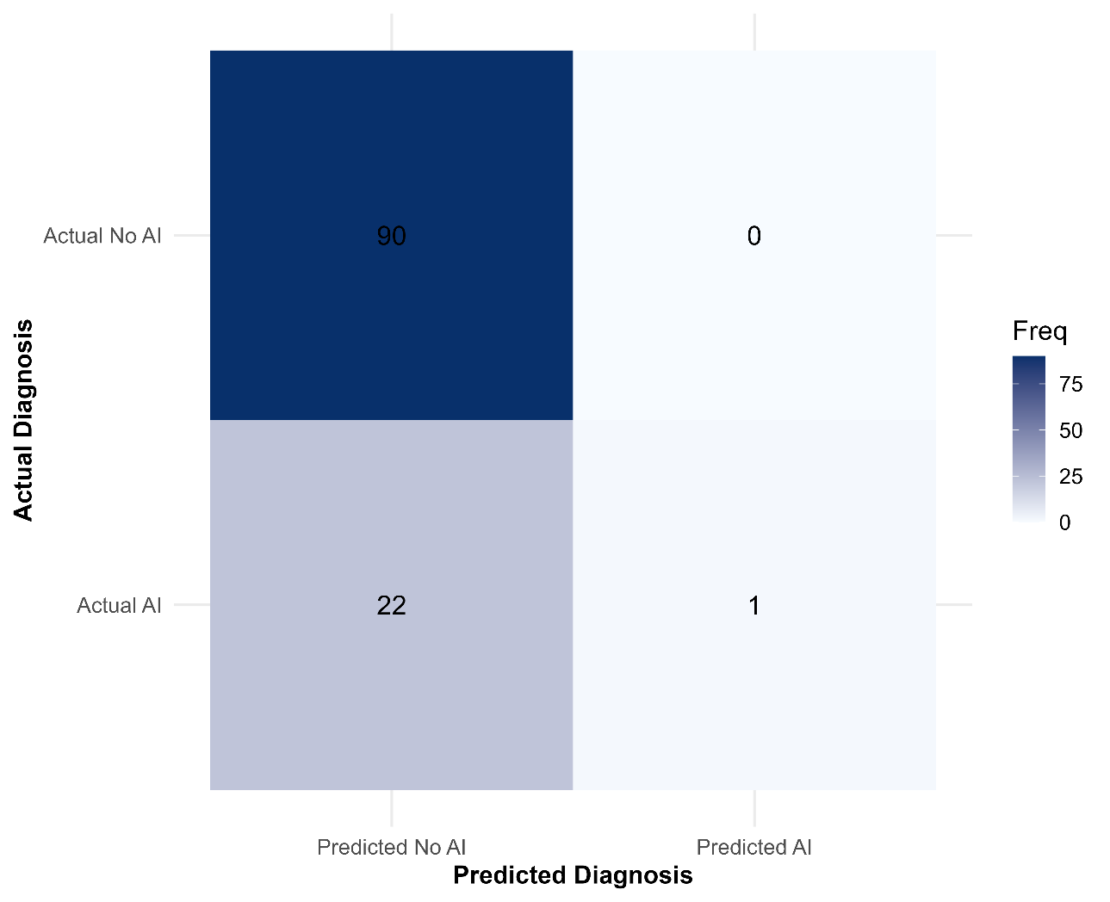
Figure 3. Classification performance of the optimized neural network model on the unseen test dataset. The matrix compares the model's predicted diagnoses (Predicted AI vs. Predicted No AI) against the actual clinical diagnoses (Actual AI vs. Actual No AI). This visualization quantifies the model's accuracy, detailing the number of correct predictions (true positives and true negatives) and errors (false positives and false negatives).

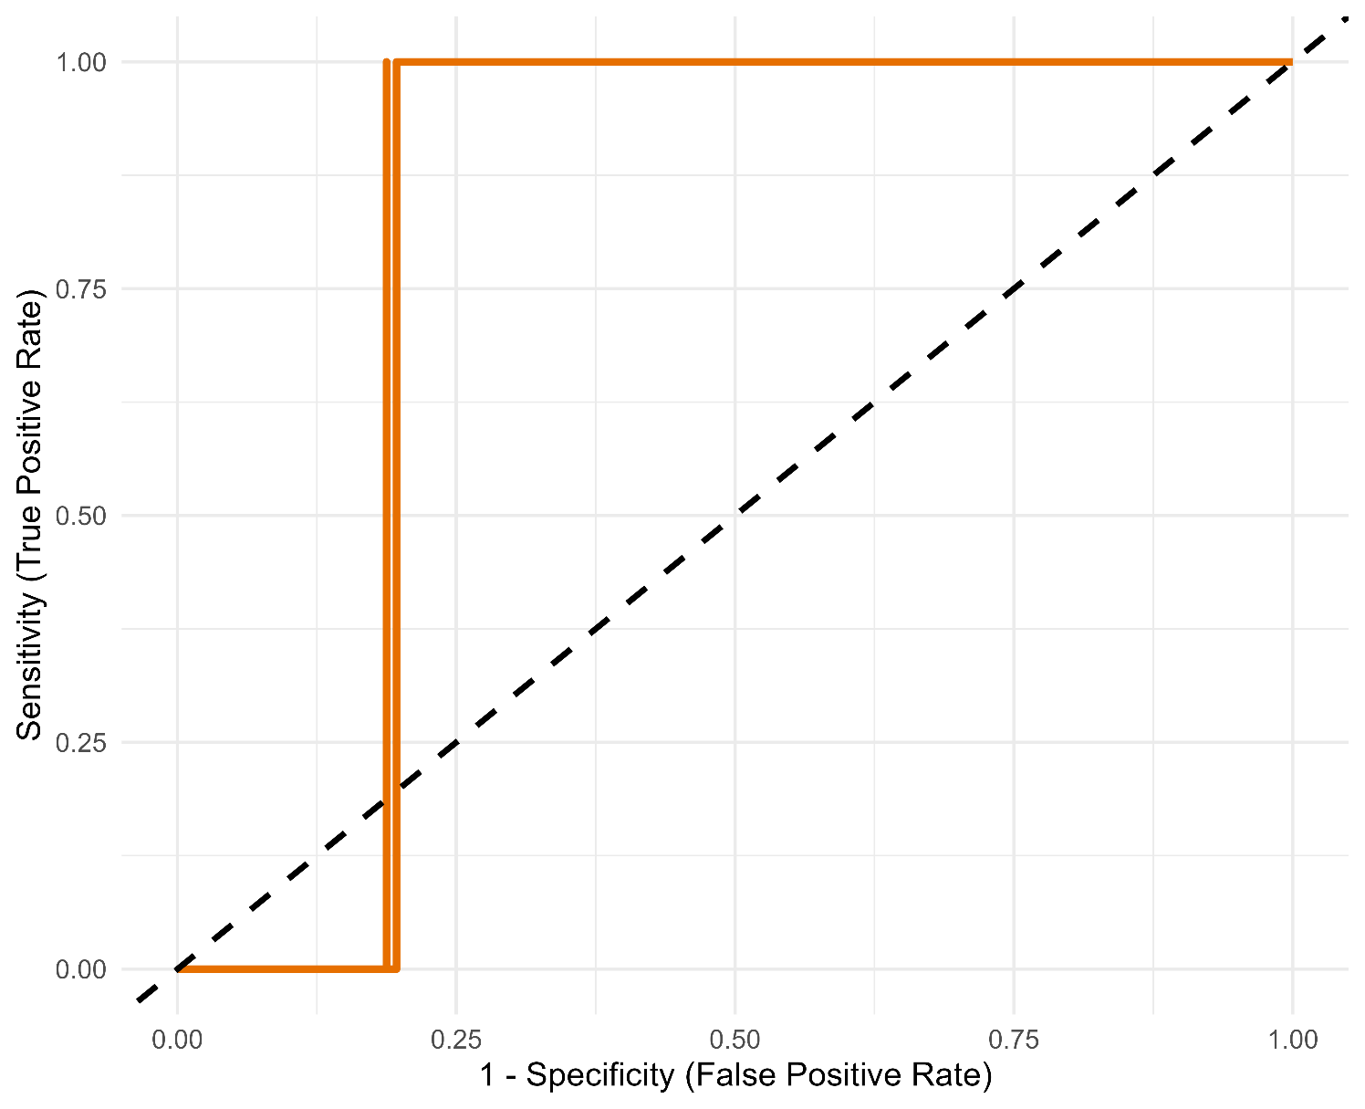

Fig 4: Receiver Operating Characteristic (ROC) curve evaluating the diagnostic performance of the artificial intelligence model. The curve illustrates the trade-off between sensitivity (True Positive Rate) and 1-specificity (False Positive Rate) across all possible diagnostic thresholds. An Area Under the Curve (AUC) of 0.812 indicates a high degree of diagnostic accuracy, demonstrating the model’s strong ability to distinguish between patients with and without adrenal insufficiency.

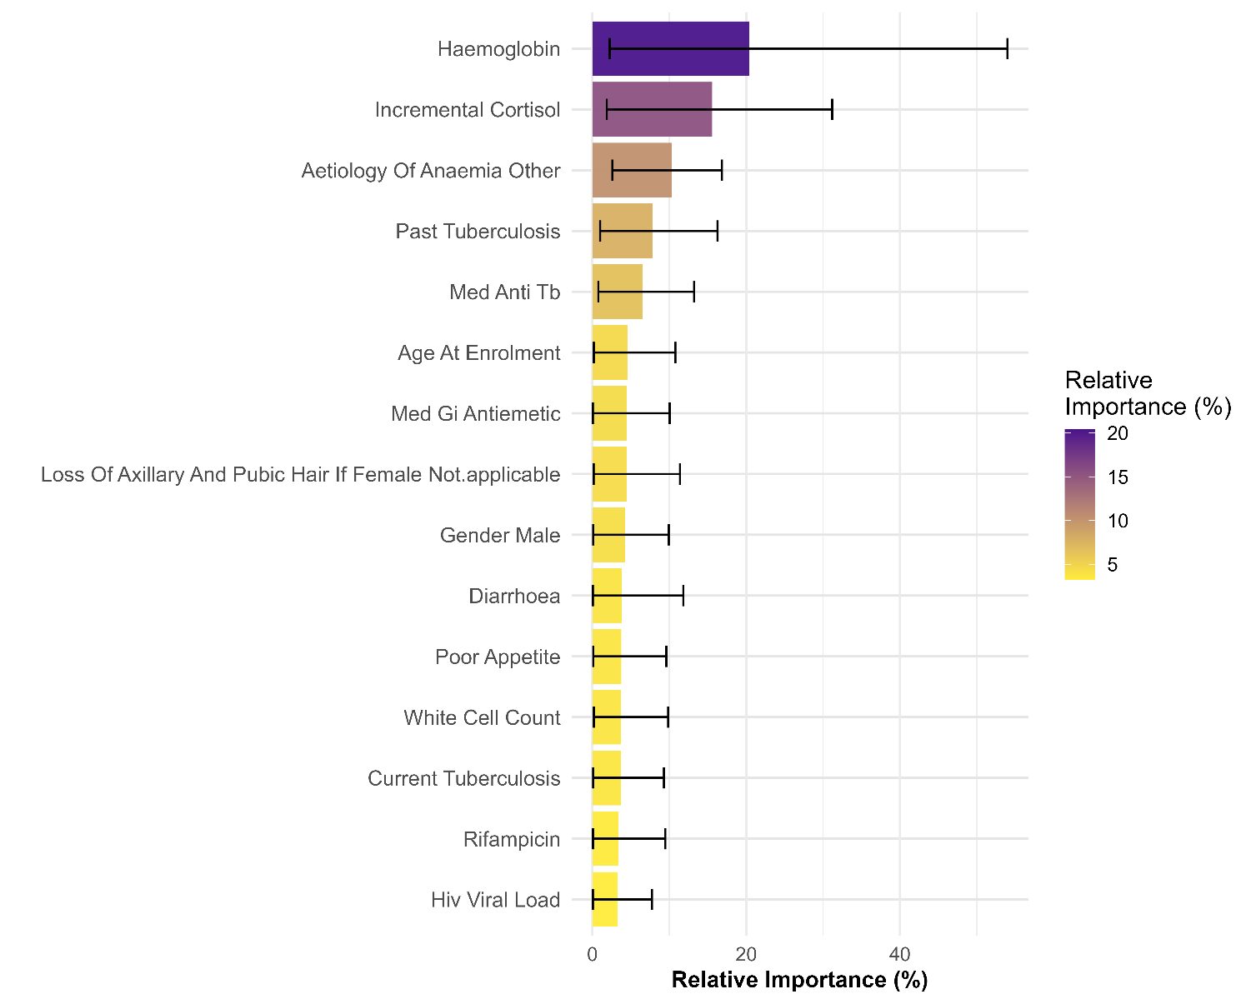

Figure 5. Aggregated feature importance for the prediction of adrenal insufficiency (AI). The chart ranks clinical and demographic variables based on their predictive power, with importance scores averaged across the top 10 best-performing models. The length of each bar represents the mean relative importance, while the error bars indicate the standard deviation, illustrating the consistency of each feature's contribution to the model's predictions.

